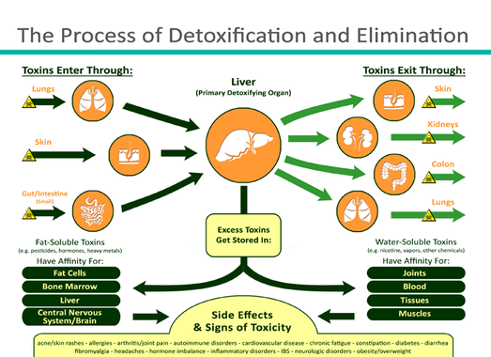

Why Detox?

Just like dusting your furniture and cleaning your bathrooms, the human body needs to be cleaned, too. Especially if you have a diet that includes packaged foods, hydrogenated fats and oils, white flour and sugar, or if you are exposed to:

* Second-hand smoke
* Fertilizers
* Garden pesticides
* Vehicle fumes
* Dust
* Mold
* Mildew
* Animal dander
* Electrical devices
* Household cleaners
* Photocopiers
* Pollution
* Smog
* Smoke
* Heavy metals
* Paint fumes
* Dry cleaned clothing
* Rain

**Here is a checklist of symptoms to see if it might be time for a cleansing:**

* Fatigue or low energy levels
* Brain fog, lack of concentration and /or poor memory
* Sugar cravings
* Less than two bowel movements per day
* Sleepy after meals, bloated or gassy
* Indigestion/acid refluxing
* Overweight. Underweight
* Recurring yeast infections, jock itch, or foot fungus
* Arthritis aches and pains or stiffness
* Taking prescription medications, sedatives or stimulants
* Frequent headaches and/or migraines
* Living with or near polluted air, water or other environmental pollution
* Bad breath or excessive body odor
* If you experience depression or mood swings
* Food allergies or skin problems
* Eat fast food, fatty foods, pre-prepared foods or fried foods more than three times a week
* Drink processed coffee and/or soda pop

**If you checked three or more of the above,   
it may be time to DETOX**