Cozy Lentil Soup

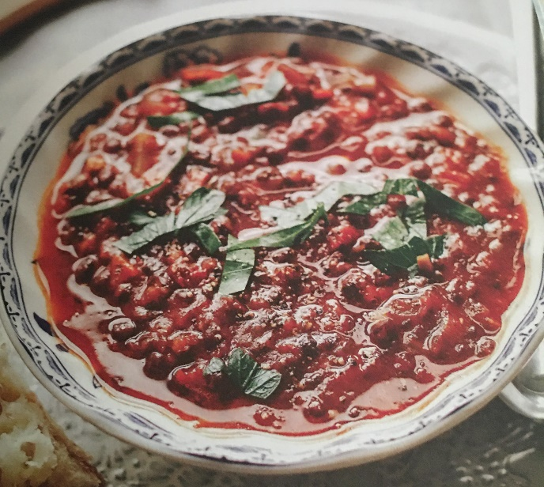
Serves 10
Ingredients:
3 T. olive oil
1 medium yellow onion – small dice
1 tsp. thyme
½ tsp. smoked paprika
½ tsp. dried tarragon
2 medium carrots – small dice
2 stalks celery – small dice
salt & pepper – to taste
4 cloves garlic – minced
1 C. French lentils – rinsed
1 can (14 oz) crushed tomatoes (can use fire roasted)
1 can (14 oz) diced tomatoes (can use fire roasted)
6 C. vegetable stock
(Note: you can add any small dice root vegetable to this for even more nutritional value. Beets, parsnip, turnip, etc. If needed you can add additional vegetable stock for the consistency you want.)
(Note: you can use any type of lentil however French lentils keep their shape during cooking while red and others may lose their shape. I use whatever I have on hand.)
In a large, heavy bottomed pot, heat the olive oil over medium heat. Add the onions to the pot and stir. They should be sizzling but just barely. Continue to stir and sauté the onions until they are completely soft, about 8 minutes.
Add the thyme, smoked paprika, and dried tarragon. Stir the spices in and cook until fragrant, about 1 minute.
Add the carrots and celery (and any other root vegetable) to the pot and stir. Season with salt and pepper. Sauté the vegetables until barely softened., about 2 minutes. Add the garlic and stir until fragrant, about 30 seconds.
Add the rinsed lentils to the pot and stir to coat them in the oil, spices, and vegetables. Add the crushed and diced tomatoes and stir to combine. Add the vegetable stock and stir once more.
Cover the soup and bring to a boil. Reduce the heat to a simmer and adjust the lid slightly askew, allowing some steam to escape.
Simmer until the lentils are tender, stirring occasionally, about 25 minutes. Check the soup for seasoning, adjust accordingly, and serve hot.
Leftovers can be frozen in flat bags or canned in pint jars.

