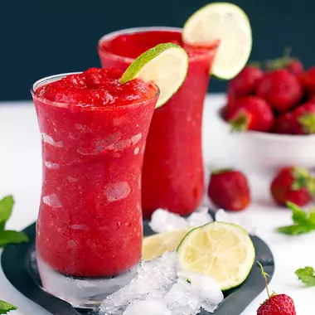
Frozen Fruit Slushie Recipe
This is a great treat that satisfies a sweet tooth. The added lime or lemon gives makes it even more satisfying.

½ cup of any frozen berry
1 Tablespoon lime or lemon juice
Add enough water to get the right consistency
Blend well.

