Sweet Potato Black Bean Burrito

3 servings

2 medium sweet potatoes, peeled and cubed

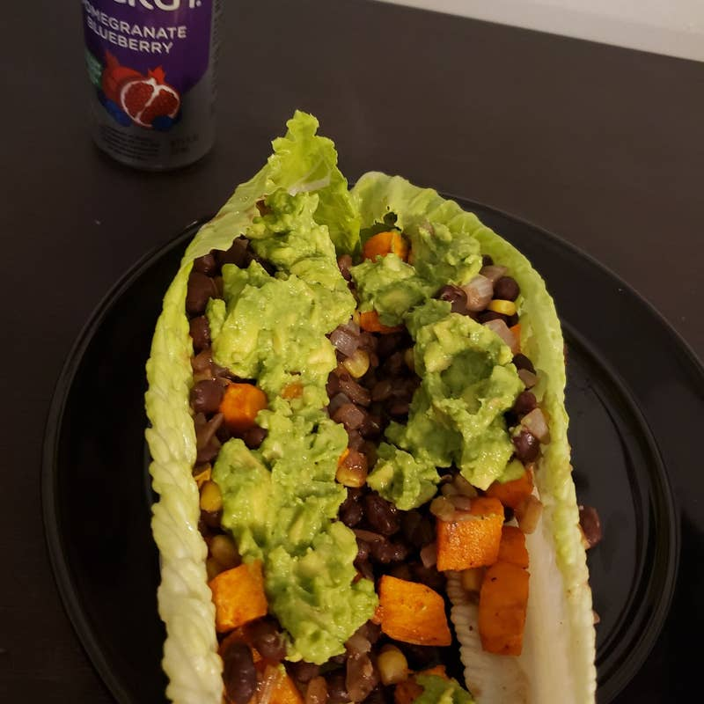olive oil, to taste

½ teaspoon smoked paprika

½ teaspoon garlic powder

kosher salt, to taste

pepper, to taste

½ medium yellow onion, diced

1 jalapeño, seeded and diced

1 clove garlic, minced

1 teaspoon chili powder

½ teaspoon ground cumin

cayenne pepper, to taste

15 oz black beans, 1 can, drained and rinsed

¾ cup corn – non-GMO only

3 large flour tortillas or GF tortillas or lettuce wraps

lettuce, chopped, for serving

diced tomato, for serving

shredded vegan or raw cheddar cheese, for serving

guacamole, for serving

Instructions:

Preheat the oven to 400°F (200°C).

Add the sweet potatoes to a baking sheet with a drizzle of olive oil, the paprika, garlic powder, salt, and pepper. Toss until well coated.

Bake for 20 minutes, flipping halfway through, until the sweet potato is tender.

Heat a drizzle of olive oil in a large saucepan over medium heat. Once the oil begins to shimmer, add the onion and cook for 3-4 minutes, until semi-translucent. Add the jalapeño, garlic, chili powder, cumin, and cayenne pepper and cook for 2-3 minutes, until the spices are fragrant. Add the black beans and corn, season with salt and pepper, and cook until warmed through, 3-4 more minutes.

To assemble a burrito, add ⅓ of the bean and corn mixture, ⅓ of the roasted sweet potatoes, some lettuce, tomatoes, vegan cheese, and guacamole to the center of a tortilla. Fold in the sides and roll up, keeping the filling tucked in place. Repeat with the remaining ingredients. Cut in half and serve.

Enjoy!