**Week 1**

Recipes are four (4) servings each. You can refrigerate (if using within three days) or freeze leftovers for another day. We recommend freezing flat in freezer Ziplock’s, so they stack easily and are easy to thaw.

If you are feeding a larger family, recipes can be doubled.

V = Vegetarian. However, if you want to you can add a meat to any of the vegetarian dishes.

**BREAKFAST**

See “Protein Shake Recipes” tab. Enjoy one shake every morning to fuel your body!

**LUNCH**

Enjoy a second shake if weight loss is your goal or if you are on the go.

If not, dinner leftovers, a healthy salad, or clean meal are your choices.

**DINNER**

Monday (Day 1): Easy one-pan chicken bake

Tuesday (Day 2): One-pan pasta with broccoli and tomatoes (V)

Wednesday (Day 3): Simple ginger salmon with vegetable stir fry

Thursday (Day 4): Minestrone soup (V option. Use vegetable stock instead of chicken stock.)

Friday (Day 5): Smoky beef and bean chili (V option. Leave out beef and add an extra can of your choice of beans; use vegetable stock instead of chicken stock.)

**Week 1 Grocery List**

How to read grocery list:

number to left of item = quantity, if no number assume quantity is 1

number to right of item = what meal number the item is needed for (see dinner list for numbers) If there’s a brand we personally prefer, it’s listed in ().

You will be able to find these items at stores like Whole Foods, Trader Joes and in the natural or organic section of some conventional grocery stores like Kroger & Meijer. Farmers Markets are a great place to get local, more organic, less expensive fruits and veggies in the spring, summer and fall. Check online for local markets, some are open year around. You may want to see if you can join local farmers CSA (Farm Share)

You are trying to eat as clean as possible to decrease your toxic load, so choose organic/non-GMO options whenever available and as much as your budget will allow. Remember to use your Dirty Dozen/Clean 15 shopping list for your produce.

**PRODUCE**

|  |  |  |
| --- | --- | --- |
| **Quantity** | **Item** | **Meal Number** |
| 5 | Medium red onion | 3, 4, 5 |
| 3 | Small red pepper | 3, 5 |
| 1 | Small yellow or orange pepper | 5 |
| 1 | 8 oz baby spinach | 1 |
| 1 | Sweet potato | 5 |
| 2 | Lemons | 2 |
| 3 | Heads of garlic | 1, 2, 3, 4, 5, |
| 17 oz | Broccoli | 2, 3 |
| 11 oz | Cherry tomatoes | 2 |
| 2 handfuls | Fresh basil | 2, 4 |
| 1.5 oz | Fresh ginger | 3 |
| 4 | Spring onions | 3 |
| 4 | Large carrots | 3, 4 |
| 1 | 6 ounces riced cauliflower | 3 |
| 6 oz | Sugar snap peas **or** fresh green beans | 3 |
| 3 | Leeks | 1, 4 |
| 7 oz | Fresh or frozen green beans | 4 |
| 2 | Large zucchini | 4 |
| 1 | Avocado (optional) | 5 |
|  |  |  |
|  | **REFRIGERATED** |  |
| **Quantity** | **ITEM** | **Meal Number** |
| 1 | Whole chicken | 1 |
| 4 oz | Unpasteurized raw milk Parmesan cheese (optional) or Daiya non-milk brand | 2, 4 |
| 4 | Salmon fillets 4 to 5 oz each | 3 |
| 1 pound | Grass fed ground beef | 5 |
| 4 oz | Plain grass-fed milk yogurt with live cultures (optional) | 5 |
|  |  |  |
|  | **FROZEN** |  |
| **Quantity** | **ITEM** | **Meal Number** |
| 1 bag | Frozen mixed berries (optional) | Shakes |
| 1 bag | Frozen strawberries (optional) | Shakes |
|  |  |  |
|  | **PANTRY** |  |
| **Quantity** | **ITEM** | **Meal Number** |
|  | Extra virgin olive oil | 1, 2, 3, 4, 5 |
|  | Smoked paprika | 5 |
|  | Dried thyme | 1 |
|  | Himalayan or Celtic sea salt | 1, 2, 3, 4, 5 |
|  | Black pepper | 1, 2, 3, 4, 5 |
|  | Dried chili flakes | 2, 3 |
| 2 | 14.5 oz cans butter beans (lima beans) |  |
| 2 oz. | Pine nuts | 2 |
| 7 oz. | Gluten free spaghetti noodles | 2 |
| 2 oz. | Cashew nuts | 3 |
| 2 Tbsp. | Coconut aminos | 3 |
| 4 servings | Organic brown rice | 5 |
| 2 Tbls. | Raw honey | 3 |
| 3 | 14.5 oz. can diced tomatoes | 4, 5 |
| 1 | 6 oz. can tomato paste | 4, 5 |
|  | Dried Italian seasoning | 4 |
| 4 quarts | Chicken stock | 1, 4, 5 |
| 2 | 14.5 oz. can cannellini beans | 4 |
|  | Coriander | 5 |
|  | Cumin | 5 |
|  | Turmeric | 5 |
|  | Chili powder | 5 |
| 1 | 14.5 oz. can kidney beans | 5 |
| 1 | 14.5 oz. can black beans | 5 |

**Recipes Week 1**

**Monday (Day 1): Easy One-Pan Chicken Bake**

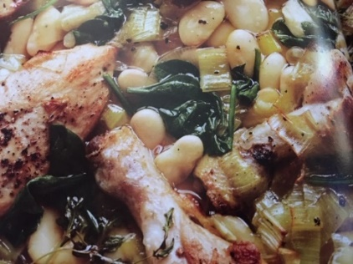

Serves: 4

**INGREDIENTS:**

1 whole chicken, cup up, skin removed (bones left in)  
Sea salt

Black pepper

1 tablespoon extra virgin olive oil

1 leek, trimmed, halved lengthwise, and sliced

1 head garlic, cut in half horizontally

2 cups chicken stock

¼ cup water

1 teaspoon dried thyme

2 (14.5 oz) cans butter beans (lima beans), drained and rinsed

8 ounces baby spinach leaves

**INSTRUCTIONS:**

1. Preheat oven to 350 F.
2. Season the chicken with salt and pepper
3. Place a large metal roasting pan on the stovetop to heat up over medium-high heat. Add the oil. Once the oil is hot, brown the chicken pieces on all sides until nicely colored. Turn the chicken side up.
4. Add the garlic to the pan, cut side down, then add the leek slices and stir around in the oil.
5. Pour in the chicken stock and water. Use a wooden spoon to scrape up any bits stuck to the bottom of the pan.
6. Turn off the heat and add the thyme, butter/lima beans, and spinach, nestling them between the chicken pieces.
7. Season with a pinch of salt and pepper and mix everything together, then put the pan into the oven.
8. Bake for 35 to 40 minutes until the chicken is cooked through. Give the contents of the pan a stir occasionally to make sure everything is cooking evenly.
9. Remove the pan from the oven and leave to rest for 5 minutes before serving in shallow bowls.

**Tuesday (Day 2): One-Pan Pasta with Broccoli and Tomatoes**

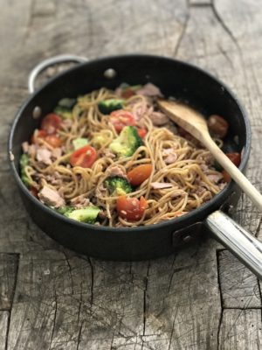

Serves: 4

**INGREDIENTS:**

7 ounces gluten free spaghetti

11 ounces broccoli, cut into small florets and halved

11 ounces cherry tomatoes, halved

4 garlic cloves, peeled and very thinly sliced

4 tablespoons extra virgin olive oil

¼ - ½ teaspoon dried chili flakes (depending on taste)

4 tablespoons fresh lemon juice

Sea salt and black pepper

2 ounces Daiya (or unpasteurized raw milk) Parmesan cheese

2 ounces pine nuts (optional)

Handful of fresh basil leaves, roughly torn or shredded

**DIRECTIONS:**

1. Cook pasta according to package directions in a large pan or pot.
2. During the last two minutes of pasta cooking time add the broccoli.
3. Pour off most of the excess water and return pan with pasta and broccoli to the stove.
4. Add the tomatoes, garlic, olive oil, chili flakes, and lemon juice. Season with salt and pepper. Cook for 2 – 3 minutes, tossing with two wooden spoons until the spaghetti is lightly coated with the spices and the tomatoes are softened but still holding their shape.
5. Sprinkle the parmesan, scatter with pine nuts (optional) and basil.
6. Serve with a side salad of fresh lettuce, veggies, and vinaigrette dressing.

NOTE: The broccoli can be swapped out with asparagus in season. Any pasta shape does well in this recipe – just be sure to cook according to package directions and drain off any excess water. If you want to add meat, you can add a can of drained tuna or salmon. Or serve with chicken (leftovers from meal #1 go well here). Use extra veggies if you like to add even more veggie value to this meal.

Chef tip: I love to cook my noodles in stock to add even more flavor. I use enough stock to cook the noodles, so the noodles absorb most of the liquid. This recipe is taken to the next taste level when you use beef or chicken stock instead of water to cook the noodles. If there is a little stock left over after cooking the noodles just add it right into the dish.

**Wednesday (Day 3): Simple Ginger Salmon with Vegetable Stir Fry and Brown Rice.**

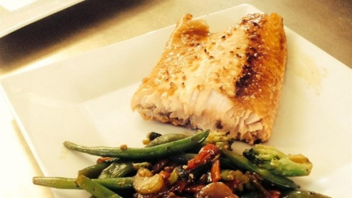

Serves 4

**INGREDIENTS:**

**(Ginger Salmon)**

1.5 ounces fresh ginger

2 tablespoons raw honey

2 tablespoons coconut aminos

2 garlic cloves, peeled and crushed

¼ - ½ teaspoon dried chili flakes (depending on taste)

4 salmon fillets, 4 – 5 ounces each

4 spring onions

Sea salt and black pepper

**(Simple Vegetable Stir-Fry)**

2 tablespoons extra virgin olive oil

1 medium red onion, peeled and cut into thin wedges

2 large carrots, peeled and thinly sliced

2 small red peppers, deseeded and thinly sliced

6 ounces sugar snap peas, trimmed **or** fresh green beans

6 ounces broccoli, trimmed and cut into short lengths

6 ounces of riced cauliflower

2 ounces cashew nuts

3 tablespoons coconut aminos

**DIRECTIONS:**

**(Ginger Salmon)**

1. Preheat the oven to 375 F and lightly oil a shallow baking dish.
2. Peel the ginger and thinly slice. Pile the ginger slices up into small stacks and cut into very fine matchsticks. Place into a medium bowl.
3. Add the coconut aminos, honey, garlic, and chili flakes and mix well.
4. Add the salmon and fully coat in the sauce. (If you have time, you can cover the dish and marinate the salmon in the fridge for 30 minutes or up to 8 hours before cooking.)
5. Put the salmon filets into the prepared baking dish, skin side down, and spoon over the mixture. Trip and cut the spring onions into roughly 1-inch lengths. Sprinkle over the salmon and season with salt and pepper.
6. Bake salmon for 15 minutes or until just cooked through.
7. Place salmon on plates, discarding the skin. Spoon onion mixture and hot cooking liquid over the fish and serve with stir-fried veggies.

**(Simple Vegetable Stir-Fry)**

1. In a dry pan over medium low heat lightly toast the cashew nuts, watching carefully so they don’t burn. About 5 minutes. Remove from pan and set aside.
2. Heat the oil in a large non-stick pan or wok and stir-fry the cauliflower for 3 minutes. Add 1 tablespoon coconut aminos.
3. Add the remaining vegetables and stir for 3 – 4 minutes or until tender. Season with coconut aminos and cook for a few more seconds. Add the cashew nuts and serve. Add sea salt if necessary to taste.

NOTE: Look out for different colored veggies that will add diversity to your meals.

**Thursday (Day 4): Minestrone Soup**

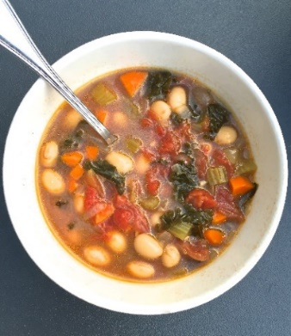

**NOTE: Serves: 6 - 10**

**Ingredients:**

4 tablespoons extra virgin olive oil

2 medium red onions, peeled and finely chopped

4 garlic cloves, peeled and finely chopped

2 medium leeks, trimmed and cut into ½ inch slices (see note below)

2 carrots, cut into ½ inch slices  
 2 (14.5 oz) cans diced tomatoes

6 tablespoons tomato paste

2 teaspoons dried Italian seasoning

3 quarts chicken stock

2 (14.5 oz) cans cannellini beans, drained and rinsed

2 zucchini, cut into ½ inch slices (if very large cut in half lengthwise first)

7 ounces green beans, cut into 1-inch lengths

Sea salt and black pepper to taste

2 ounces grated Parmesan (Daiya or unpasteurized raw milk) and fresh chopped basil leaves to serve

**Directions:**

1. Heat the oil over medium-low heat in an large stock pot and gently cook the onion for 3 minutes, or until softened and lightly colored, stirring often.
2. Add the garlic, leek, and carrot to the pan and stir over low heat for 5 minutes.
3. Add the diced tomatoes, tomato paste, Italian seasoning, and chicken stock and bring to a low boil. Cook for 10 minutes, stirring occasionally.
4. Add the canned beans, zucchini, and green beans. Return to a simmer and cook over medium-low heat until the green vegetables are just tender, stirring regularly.
5. Season the soup with a little salt and lots of black pepper. Ladle into deep bowls. Top with grated parmesan and basil leaves.

Chef tip: Leeks have an excellent flavor, are very healthy, and can often take the place of onions. To prepare leeks cut off ½ inch of the root end. Lay the leek down on a cutting board and slice in half lengthwise. You will then be able to see all the layers. Wash well under cold running water as dirt likes to hide between the layers but try to keep the layers together. Once washed, lay flat on cutting board and slice ½ inch slices.

Leftover tip: This soup freezes well. Allow to completely cool then transfer into quart or gallon Ziplock freezer bags (depending on size of family). Lay flat in freezer. When you want to prepare, remove from freezer and allow to thaw in the refrigerator overnight. Pour into pot and reheat.

**Friday (Day 5): Smoky Bean and Beef Chili**

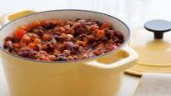

**Serves 4**

**Ingredients:**

1 pound grass fed ground beef (or ground turkey)

2 tablespoons extra virgin olive oil

2 medium red onions, peeled and thinly sliced

1 yellow or orange pepper, deseeded and cut into ½ inch chunks

1 red pepper, deseeded and cut into ½ inch chunks

1 sweet potato cut into 1-inch chunks

2 teaspoons ground coriander

1 teaspoon ground cumin

2 teaspoons ground turmeric

2 teaspoons ground smoked paprika

2 teaspoons ground chili powder

2 garlic cloves, peeled and crushed

1 (14.5 oz) can diced tomatoes

2 tablespoons tomato paste

1 (14.5 oz.) can kidney beans, rinsed and drained

1 (14.5 oz.) can black beans, rinsed and drained

2 cups chicken stock

Sea salt and black pepper

4 ounces grass-fed plain live culture yogurt for topping (optional)

1 avocado (optional)

**Instructions:**

1. Heat oil in a large, deep pan. Add the beef and stir. Cook, breaking up the meat into small pieces, until almost all browned. Add onions and cook on medium heat for 5 minutes to allow to soften, stirring often.
2. Add peppers and sweet potato to the pan. Cook with onions for 3 – 5 minutes, until beginning to soften and lightly brown.
3. Add coriander, cumin, turmeric, garlic, smoked paprika, and chili powder and cook for a few more seconds, stirring constantly.
4. Add the diced tomatoes, tomato paste, drained beans, and stock to the pan. Stir to mix.
5. Season with salt and black pepper. Bring to a simmer and cook for 25 – 30 minutes or until all the vegetables are tender, stirring regularly. Add an extra splash of water or stock if necessary. Adjust seasoning to taste.

NOTE: Top chili with a spoonful of grass-fed milk plain yogurt with live cultures, sliced avocado, and/or your favorite salsa.