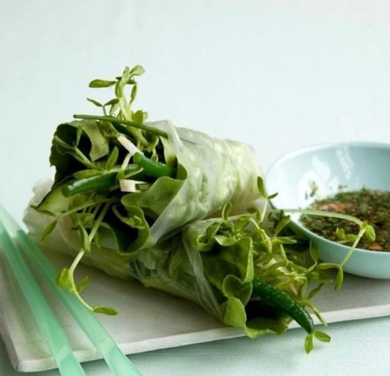**Veggie Spring Rolls**

Sweet-and-sour mint sauce is the perfect dip for this Asian favorite.

Yield: 10 rolls

**Ingredients**

* ¼ lb. green beans sliced in half lengthwise
* ¼ cup rice wine vinegar
* 2 tbsp fish sauce Nam Plah
* 2 tbsp chopped unsalted peanuts
* 2 tbsp chopped mint
* 1 tsp grated fresh ginger
* 10 spring roll wrappers
* 10 leaves Boston or Bibb lettuce
* 4 oz (3 cups) pea shoots or broccoli sprouts
* 1 bunch chives
* ¼ lb each cucumber, jicama and baby zucchini cut into thin strips

**Instructions**

1. Blanch green beans by cooking them in boiling water for 1 to 2 min; cool immediately in ice water. Drain and set aside.
2. Stir together vinegar, fish sauce, peanuts, mint, ginger and 1 tbsp water; set aside
3. Pour 1 cup warm water into a shallow dish. Dip spring roll wrappers in water one at a time, gently shaking off excess water. Place wrappers between clean, damp paper towels and let stand for 10 min. Brush any dry edges with a little water.
4. Place a lettuce leaf on the bottom half of a wrapper and top with 2 to 3 green beans, a small pile of pea shoots and chives, and a few strips each of cucumber, jicama and zucchini. Fold a roll tightly like a burrito, leaving the top end open. Repeat with remaining ingredients. Serve immediately with dipping sauce.

**Recipe Notes**

Soak wrappers in a shallow pan of room temperature water for a few seconds. Then I layer mine between damp paper towels and let them sit, and soften, about ten minutes. All that needs to happen is for the wrappers to absorb some water, and soften, no cooking needed.

Work time 40 minutes. Cook time 5 minutes.