Coconut Chicken and Butternut Curry in a Hurry

Serves 4

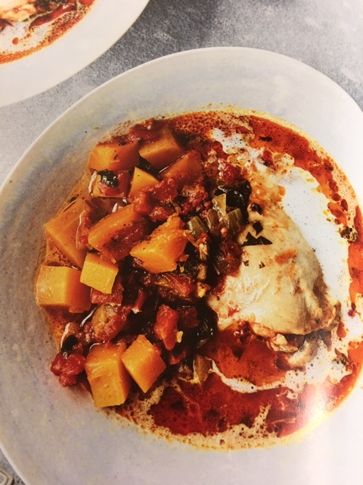Ingredients:

4 large bone-in chicken thighs skin removed and fat trimmed  
1-1/4 teaspoon Celtic sea salt  
½ tablespoon avocado oil  
½ medium onion finely chopped  
5 garlic cloves minced  
½ teaspoon ground cumin  
1-1/2 teaspoons garam masala  
2 teaspoons curry powder  
1 (14.5 oz) can petite diced tomatoes  
2 tablespoons chopped fresh cilantro plus more for garnish  
½ cup chicken broth/stock or water  
3 cups peeled and cubed butternut squash  
½ cup canned full fat coconut milk plus more (optional) for drizzling  
  
Method:

Season the chicken with 1 teaspoon of the salt.

Press the saute button on the Instant Pot. When hot, add the oil. When hot add the onion and garlic and cook, stirring, until softened, about 1 minute. Stir in the cumin, garam masala, and curry powder and cook until fragrant, about 1 minute. Add the chicken, tomatoes, cilantro, and ½ cup broth/stock/water and stir well.

Seal and cook on high pressure for 20 minutes, until chicken is cooked through. Quick release, then open when the pressure subsides. Add the butternut squash and the remaining ¼ teaspoon salt. Seal and cook on high pressure for 5 minutes, until the squash is tender. Quick release, then open when the pressure subsides.

Stir in the coconut milk.

Divide among four bowls. Garnish with extra cilantro and drizzle with coconut milk. Serve.

Note. Full fat coconut milk will separate in the can. Be sure to mix thoroughly before measuring.