Chicken and lentil soup

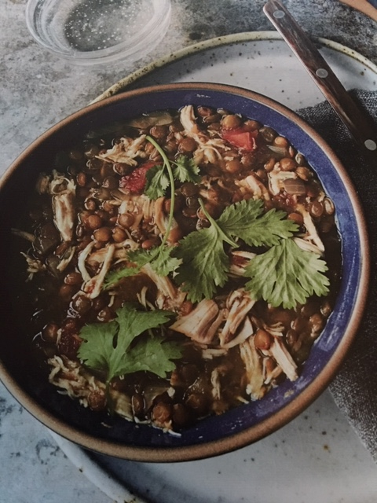Serves 8

Ingredients:

1 pound dried green or brown lentils  
¾ pound boneless, skinless chicken thighs with fat trimmed  
1 small onion chopped  
1 medium tomato chopped  
2 scallions chopped  
3 garlic cloves chopped  
¼ cup chopped cilantro  
1 teaspoon garlic powder  
1 teaspoon dried cumin  
¼ teaspoon dried oregano  
½ teaspoon sazon seasoning  
½ teaspoon Celtic or Himalayan sea salt  
7 cups chicken or vegetable stock

Method:

In an Instant Pot combine all ingredients. Stir to mix. Seal and cook on high pressure for 30 minutes. Natural release, then open when the pressure subsides. Shred the chicken (while in the pot), stir, and serve.

Sazon Seasoning

1 tablespoon ground coriander  
1 tablespoon ground cumin  
1 tablespoon ground annatto seeds or turmeric  
1 tablespoon garlic powder  
1 tablespoon Celtic or Himalayan sea salt  
2 teaspoons dried oregano  
1 teaspoon freshly ground black pepper

Combine in a small bowl. Can be stored in an airtight container for up to six months.