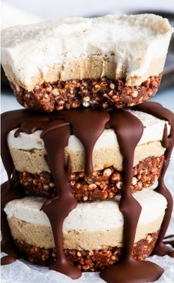Tiramisu Bites

Chocolate layer

2-2/3 oz dark chocolate   
½ Tbsp coconut oil  
1 Tbsp raw honey  
1 cup ground almonds  
1 cup puffed quinoa (or puffed rice) (Non- GMO)

Mousse-like “coffee” layer

2 cups cashew nuts that have been soaked overnight then drained  
3/8 cup raw honey  
1 Tbsp melted coconut oil  
1 – 2 Tbsp warm almond milk

Creamy vanilla layer

1-1/2 cups cashew nuts that have been soaked overnight then drained  
½ cup coconut cream  
1-1/2 Tbsp coconut oil  
¼ cup raw honey  
2 tsp vanilla extract

METHOD: Line 10 holes of a muffin tin with plastic wrap leaving enough extra plastic wrap to grab and pull out the bites later. This will make removing the frozen tiramisu bits at the end much easier.

For crunchy chocolate base: Melt the chocolate and coconut oil together and allow to cool. In a bowl, mix together all the chocolate layer ingredients. Transfer 1/8 cup of the mixture into each of the 10 muffin spots and flatten it into a compact layer. Use a 1/3 cup measure cup to flatten easily. Freeze for at least 15 minutes to firm up the layer.   
  
For mousse-like layer: In a food processor or blender, blend the soaked and drained cashew nuts until they are a smooth paste. Add the rest of the layer ingredients and blend until everything is evenly distributed. Transfer 1/8 cup of the mixture to the top of the frozen chocolate layer and smooth out the tops with a small spoon. Freeze for at least 30 minutes so the layer firms up sufficiently for the vanilla layer to be added on top

For creamy vanilla layer: In a food processor or blender, blend the soaked and drained cashew nuts until you get a smooth paste. Add the rest of the vanilla layer ingredients and blend until everything is mixed well. Transfer 1/8 cup of the mixture to the top of the firmed-up mousse layer and smooth out with a small spoon. Freeze overnight.

Final steps: The next day pull gently on the plastic wrap to remove the bites from the muffin tin. Before serving allow to thaw for 5-10 minutes. Or place into Ziplock bag and place back into freezer for future use (use within 3 weeks). Serve “as-is”, dusted with cocoa powder, or drizzled with melted dark chocolate.