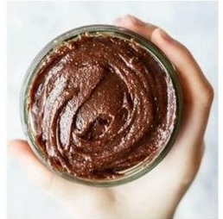Homemade Nutella

2 cups hazelnuts  
¼ cup unsweetened cocoa powder  
½ cup full fat coconut milk  
4 Tbsp raw honey  
½ tsp vanilla extract  
2 pinches Celtic sea salt

Preheat oven to 375 F. Place hazelnuts onto a baking sheet and roast for a few minutes until fragrant and slightly brown. Do not walk away as they will easily burn. Remove from oven. To peel skins, place roasted nuts into the fold of a kitchen towel and gently massage until most of the skin comes off. Place hazelnuts into food processor and process until creamy smooth (8-10 minutes). Scrape sides a few times during processing. Add remaining ingredients and process until smooth. Adjust consistency with coconut milk if too thick. Store in airtight glass container for up to one week.