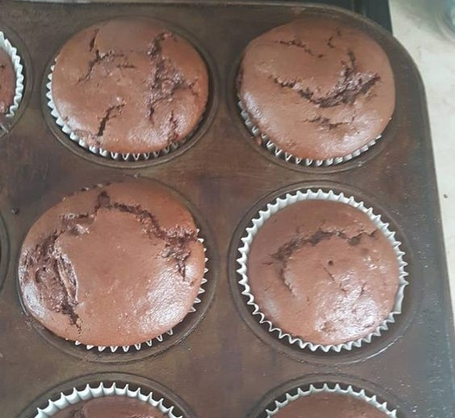Chocolate Zucchini Cupcakes

6 scoops Arbonne chocolate protein mix  
2 Tbsp unsweetened cocoa powder  
2 tsp cinnamon  
2 tsp baking powder  
2 eggs  
½ zucchini – shredded

Mix all ingredients together with a fork and place in greased (coconut oil) muffin tin. Bake at 350F for 15-20 minutes until a toothpick comes out clean.