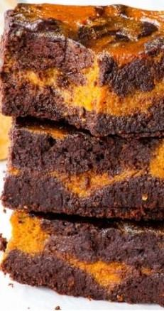CHOCOLATE PUMPKIN BROWNIES

Brownie Batter

7 oz dark chocolate  
1/4 cup coconut oil  
1/4 cup raw honey  
3/8 cup cocoa powder  
1/3 cup hot almond or coconut milk  
3 eggs  
1 tsp vanilla extract  
pinch of salt  
1 cup almond flour

Pumpin Pie Filling   
3/4 cup organic pumpkin puree  
1 egg  
1/3 cup raw honey  
pinch of salt  
1 tsp cinnamon  
1/2 tsp ground ginger  
1/2 tsp ground nutmeg  
1/4 tsp allspice  
1/8 cup coconut cream

**Prepare Brownie Batter:** In a bowl above simmering water or double boiler melt together the chocolate and coconut oil Leave to cool until warm. Add honey, cocoa powder, eggs, vanilla, and salt then mix well. Add the hot almond milk and mix until smooth. Add almond flour and mix until no clumps.

**Prepare Pumpkin Pie Filling:** Mix all pumpkin pie filling ingredients together until smooth. Preheat oven to 350 F (175 C) and line and 8 x 8-inch baking pan with parchment paper. Transfer 2/3 of the brownie batter into the baking pan and smooth out. Pour the pumpkin pie filling on top of the brownie batter. Spoon portions of the remaining browning batter on top of the pumpkin pie filling. Using a spoon, fork, or spatula, create a swirl on top. Bake in preheated oven for 26-28 minutes or until the middle is no longer wobbly but an inserted toothpick still comes out "dirty".

Allow to cool then cut into squares. Can be frozen.