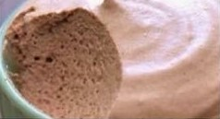Chocolate Mousse (Pudding)

1 scoop Arbonne chocolate protein powder  
1 Tbsp almond butter  
1/8 tsp almond extract  
Splash of almond milk

Blend all ingredients until smooth. Enjoy.