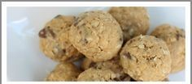

Chocolate Chip Protein Cookies

1 scoop Arbonne vanilla protein shake mix  
¼ cup chocolate chips  
1/3 cup organic non-GMO oats uncooked  
1 Tbsp raw honey  
2 Tbsp almond butter  
1 tsp Arbonne Green’s Balance

Mix together all ingredients then form mixture into 1-inch balls. Smash flat like a cookie then place in refrigerator to firm up. Enjoy!