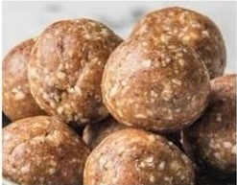Basic Arbonne Protein Balls or Bars

2 cups almond butter (creamy or crunchy)  
½ cup raw honey  
4 cups Arbonne protein powder (your choice of flavor)  
2-1/2 cups dry uncooked organic oatmeal  
Melted coconut oil for consistency  
  
Method: Over a double boiler or in a pan over very low heat combine almond butter and honey until melted and mixed together. Add protein powder and oats and mix thoroughly. Roll into balls or press into baking pan for bars. Refrigerate one hour, or until solid enough to cut into bars.

Add-in’s: Feel free to add organic raisins, cranberries or other dried fruits and/or nuts. If adding other ingredients you may need to add melted coconut oil for consistency.