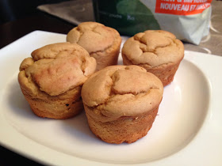Arbonne Vanilla Cupcakes (with variations below)

4 scoops Arbonne vanilla shake mix  
1 tsp vanilla extract  
1 tsp baking powder  
1 egg  
¼ cup egg whites  
¼ cup unsweetened almond milk  
  
Use a large fork to mix all the ingredients together. Use coconut oil to oil a muffin tin and pour batter filling each hold ¾ full. Bake at 350F for 20 minutes until golden on top. Makes 4 cupcakes.  
  
Variations: Add some dried fruit, ½ mashed banana, or other ingredients you like. Use the chocolate protein shake mix to make chocolate muffins.