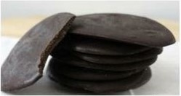Arbonne “Thin Mints”

¾ cup Arbonne chocolate protein powder  
½ cup unsweetened cocoa powder  
1 tsp. peppermint extract or one drop of peppermint essential oil  
7-8 Tbsp melted coconut oil

Place all ingredients into a bowl and stir together. Place a spoon full onto a cookie sheet covered with plastic wrap. Bang cookie sheet onto counter to flatten cookies. Freeze until set. Keep in refrigerator or freezer – wrapped well.