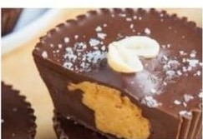Arbonne “Reese’s” Cup

2 scoops Arbonne chocolate protein powder  
6 Tbsp coconut oil  
Almond butter

Melt coconut oil then stir in Arbonne chocolate protein powder Pour half into a mini-muffin tin and freeze for 5-10 minutes. Remove from freezer and add 1 tsp of almond butter then pour the remaining chocolate mixture on top. Freeze another 5-10 minutes. Enjoy!