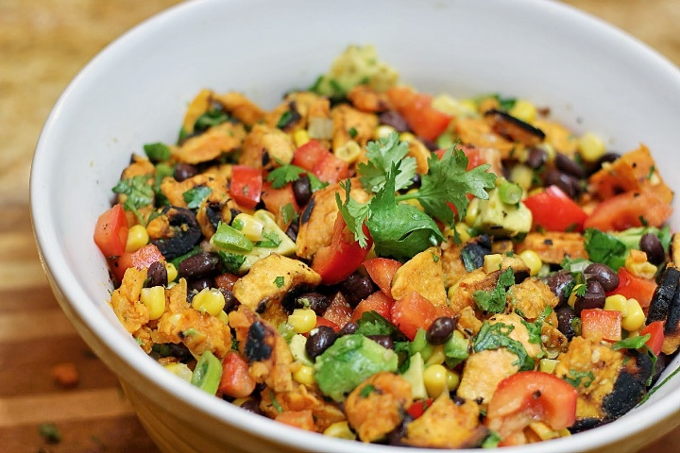Roasted Southwestern Sweet Potato Salad  
  
Serves 6

Ingredients:

4 medium sweet potatoes, peeled and cubed  
1 T. plus 1 tsp. avocado or sunflower oil  
salt and pepper to taste  
1 C. organic, non-GMO sweet corn  
1 15-oz can of organic black beans, rinsed & drained  
1 organic red pepper, diced  
2 green onions, diced  
½ cup chopped fresh cilantro  
2 organic avocado’s, pit and skin removed, diced  
Juice of 2-4 limes depending on size and taste  
Salt and pepper to taste  
  
Instructions:

In a large bowl toss the diced sweet potato pieces with oil. Spread on sheet pan then sprinkle with salt and pepper. Bake at 400F until tender. Let cool to room temperature. In a sauté pan over medium high heat place a teaspoon of oil and let get hot. Place corn into pan and allow to slightly char. Let cool to room temperature. Place sweet potatoes, corn, black beans, red pepper, green onions, cilantro, and avocado into a medium bowl and stir to mix. Add the lime juice and stir until combined. Add salt and pepper to taste. Serve. Will keep in the fridge for up to two days.   
  
Just saying….this stuff is addictive! And so healthy for you! 😊