Roasted tomato and red pepper soup (Kathe Ray)

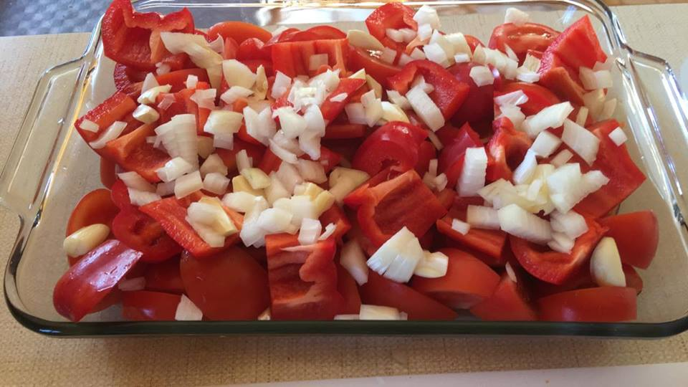

Always start with the freshest of organic and non-GMO ingredients for best results and health!

Fresh organic tomatoes, red peppers, fresh garlic head with skin removed, and a whole onion chopped. You don't need to finely chop anything because you're going to puree it later. Drizzle with olive oil then sprinkle with Celtic sea salt and pepper. Roast until tender then cool. Puree with hand blender then add chicken or veggie stock until it is the consistency you want. Finely cut fresh basil and add when finished. I also add a sprinkle of cayenne pepper. Enjoy!  
  
In the picture above I used 12 medium organic tomatoes, 2 large organic red peppers, 1 full head of garlic with skin removed and one large yellow organic onion chopped large.

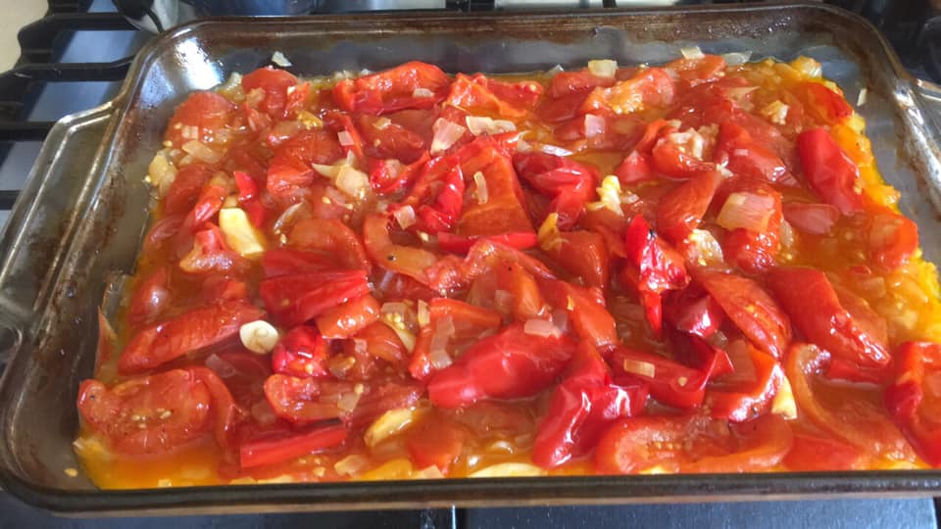Roasted at 400F for about an hour, stirring every 15 minutes. Smells AMAZING!!

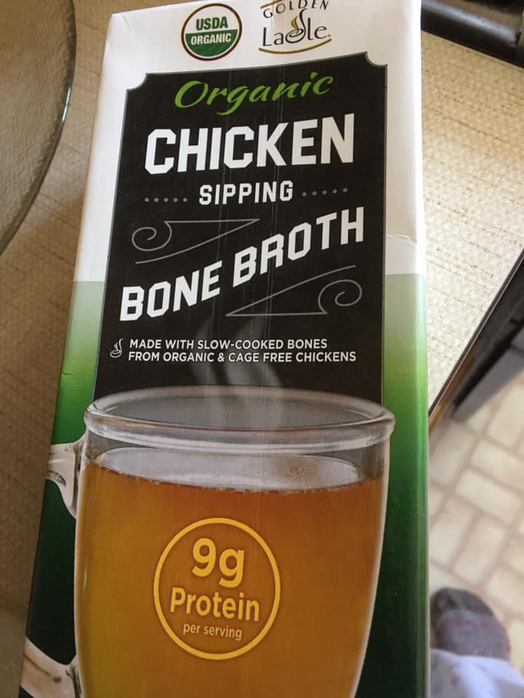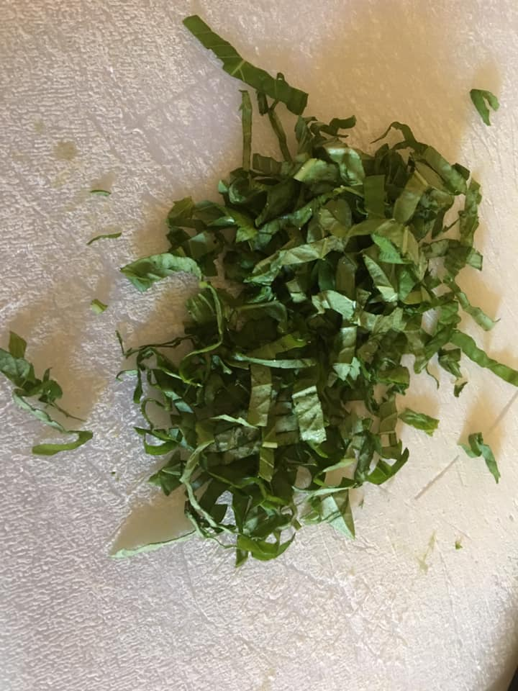Chopped fresh organic basil and organic chicken broth/stock. You can also use organic veggie stock. Bring all ingredients up to temperature over a low heat. Do not boil.

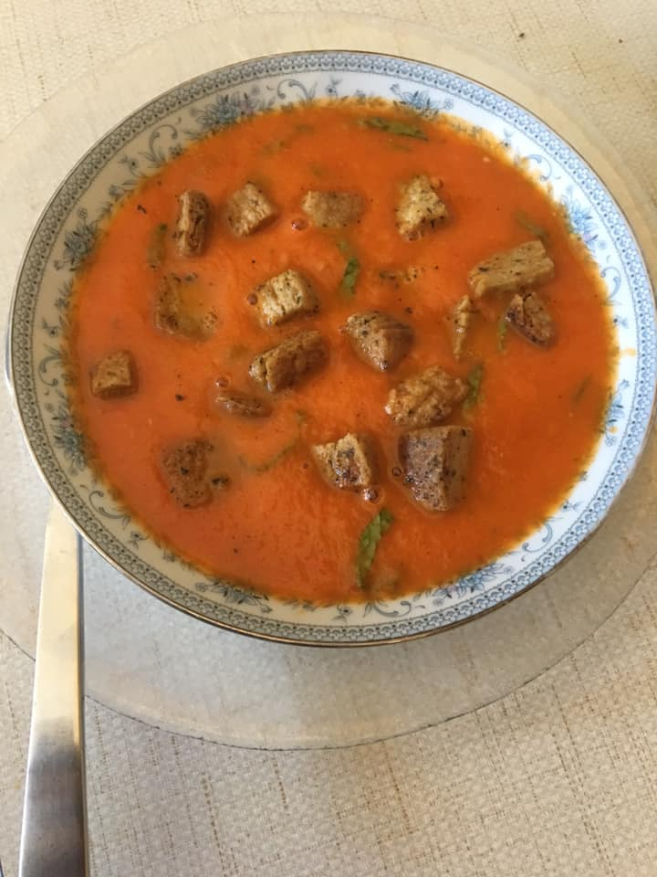

Finished with homemade croutons flavored with garlic and onion powders.