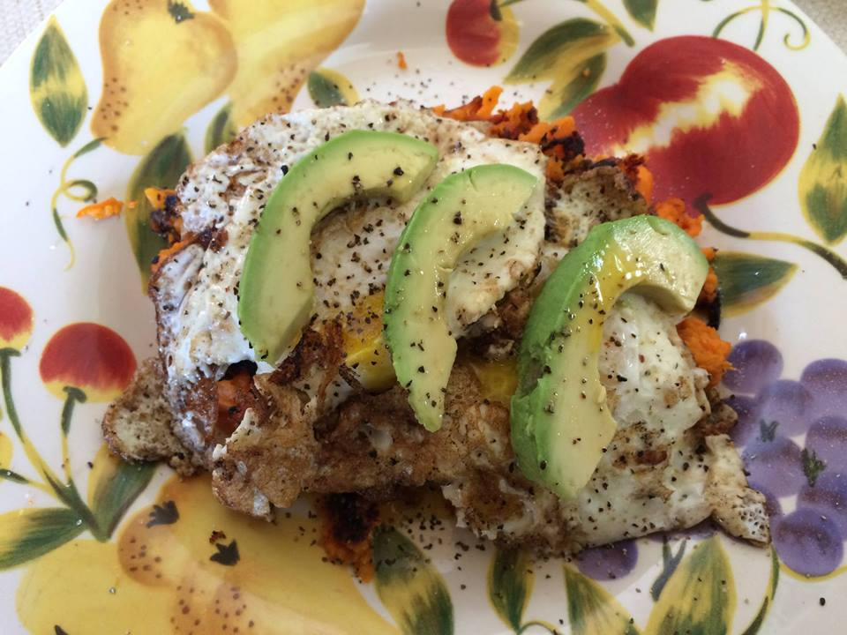

Roasted Sweet Potato, Egg, & Avocado

Great for any meal of the day!

One of our family favorite recipes! Here is another bonus recipe for you to add to your weekly meals! Yum yum!   
  
This may just be the most amazing flavor combo to ever grace my pallet!  
  
Roast/bake sweet potato 425F for 40 mins (flip at 20 mins).  
Slice in half, long-ways and peel. Heat a skillet over medium heat and add some coconut oil. Throw down your spud and mash it out a bit. Sprinkle with pumpkin pie spice (& a little cayenne if you like some spice). Let that puppy Caramelize. Trust me. The crunchy is where it's at. Heat through then remove from skillet. Add a dab more coconut oil and cook 2 (free-range) eggs over medium. (Again, trust me, you want that yolk running.) Slide those eggs atop the potato hash and then top with some sliced avocado, sea salt and fresh ground black pepper.  
  
And while you're at it...go on and roast like 7 potatoes...cuz you're gonna eat and LOVE it and want it again tomorrow. And the next day. And the next day. And the.... Seriously, how did I live without this for 35 years?!?

Variation: You can poach your eggs if you want to cut down on the oil a bit.