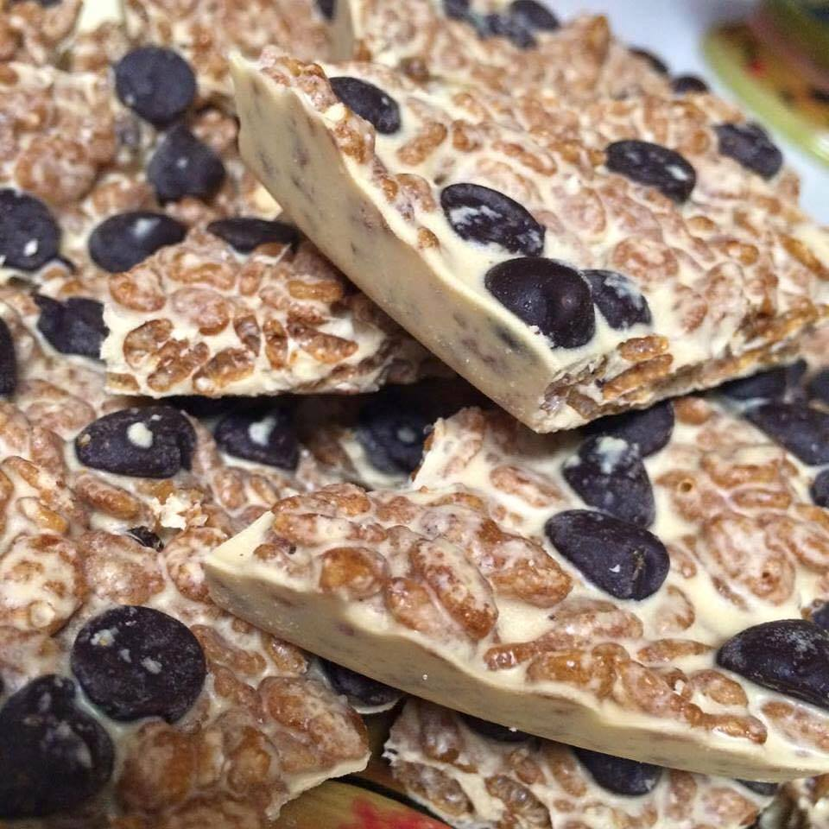Arbonne Protein Bark Recipe

5 Tbsp melted coconut oil  
3 scoops Arbonne protein powder (vanilla, chocolate or chai)  
¾ cup brown rice crisps (organic/non-GMO vanilla or chocolate flavored)

Mix ingredients together and spread on baking sheet. Top with organic mini chocolate chips. Freeze until solid. Break apart and keep in freezer bag. Enjoy!

Variations: You can add dried fruit, coconut, etc., in small amounts for variety.